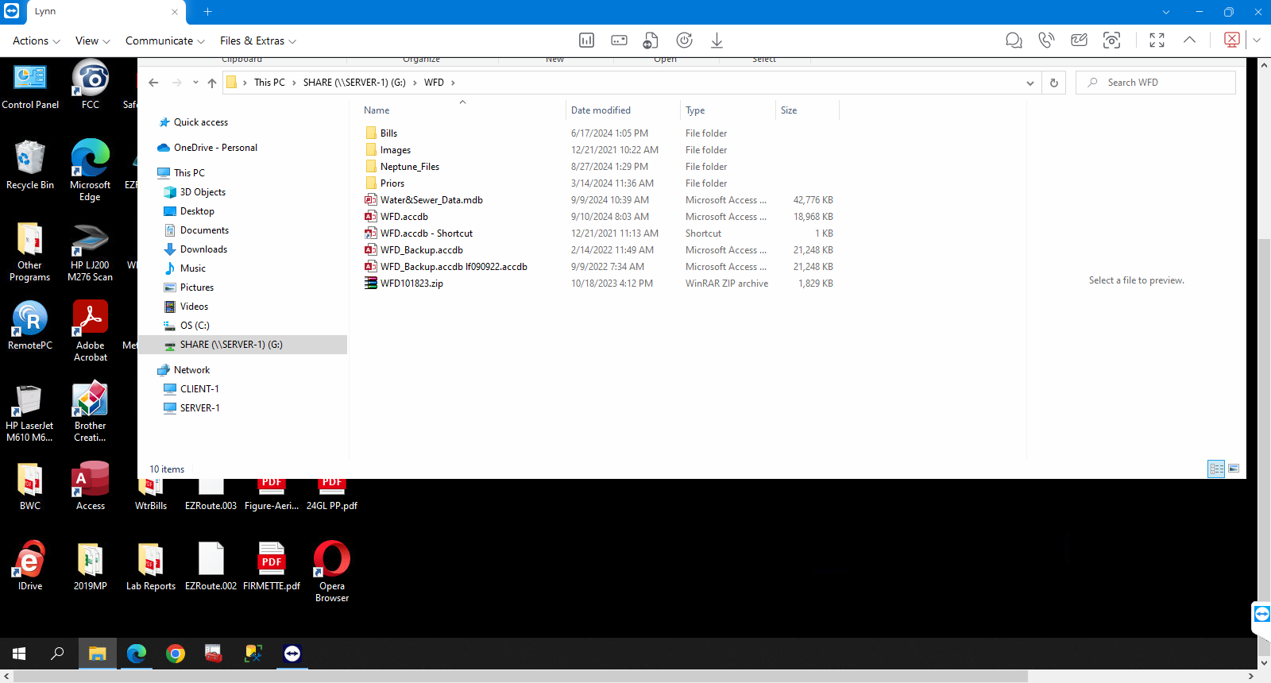

Share drive g WFD

Water sewer dat
Wrd.acb

